**Practical no.-**04

**Title:** Develop a program to display Hello World on screen

**Roll No.:**15 **Batch-** A **Date of Performance:** 04/01/2024

1. 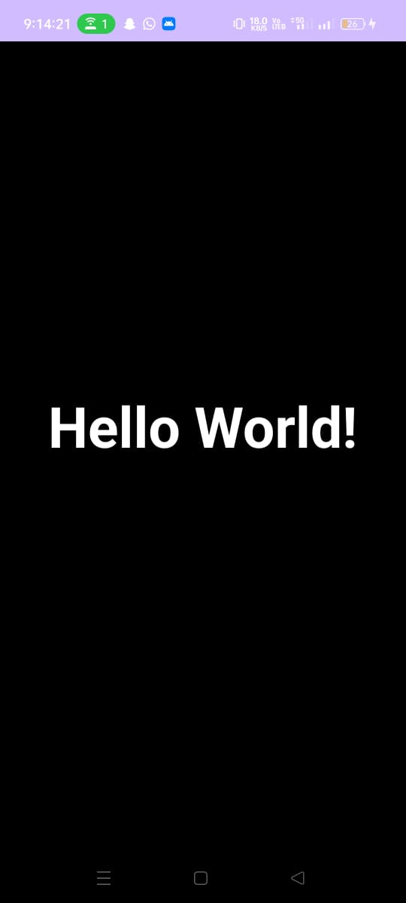

<?xml version="1.0" encoding="utf-8"?>

<androidx.constraintlayout.widget.ConstraintLayout xmlns:android="http://schemas.android.com/apk/res/android"

xmlns:app="http://schemas.android.com/apk/res-auto"

xmlns:tools="http://schemas.android.com/tools"

android:layout_width="match_parent"

android:layout_height="match_parent"

android:background="@color/black"

tools:context=".MainActivity">

<TextView

android:layout_width="335dp"

android:layout_height="103dp"

android:text="Hello World!"

android:textAlignment="center"

android:textColor="@color/white"

android:textSize="150px"

android:textStyle="bold"

app:layout_constraintBottom_toBottomOf="parent"

app:layout_constraintEnd_toEndOf="parent"

app:layout_constraintHorizontal_bias="0.493"

app:layout_constraintStart_toStartOf="parent"

app:layout_constraintTop_toTopOf="parent"

app:layout_constraintVertical_bias="0.498" />

</androidx.constraintlayout.widget.ConstraintLayout>



<?xml version="1.0" encoding="utf-8"?>

<androidx.constraintlayout.widget.ConstraintLayout xmlns:android="http://schemas.android.com/apk/res/android"

xmlns:app="http://schemas.android.com/apk/res-auto"

xmlns:tools="http://schemas.android.com/tools"

android:layout_width="match_parent"

android:layout_height="match_parent"

android:background="#000000"

tools:context=".MainActivity">

<TextView

android:id="@+id/textView"

android:layout_width="224dp"

android:layout_height="40dp"

android:layout_marginTop="104dp"

android:text="Students Info"

android:textColor="#00B0FF"

android:textSize="34sp"

android:textStyle="bold"

app:layout_constraintEnd_toEndOf="parent"

app:layout_constraintHorizontal_bias="0.497"

app:layout_constraintStart_toStartOf="parent"

app:layout_constraintTop_toTopOf="parent" />

<EditText

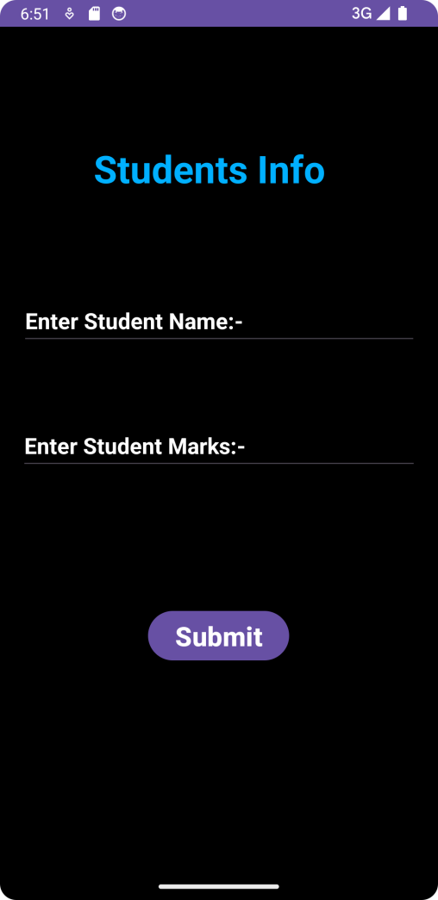 android:id="@+id/editTextText"

android:layout_width="356dp"

android:layout_height="48dp"

android:layout_marginTop="96dp"

android:ems="10"

android:inputType="text"

android:text="Enter Student Name:-"

android:textColor="#FFFFFF"

android:textSize="20sp"

android:textStyle="bold"

app:layout_constraintEnd_toEndOf="parent"

app:layout_constraintHorizontal_bias="0.509"

app:layout_constraintStart_toStartOf="parent"

app:layout_constraintTop_toBottomOf="@+id/textView" />

<EditText

android:id="@+id/editTextText2"

android:layout_width="357dp"

android:layout_height="48dp"

android:layout_marginTop="64dp"

android:ems="10"

android:inputType="text"

android:text="Enter Student Marks:-"

android:textColor="#FFFFFF"

android:textSize="20sp"

android:textStyle="bold"

app:layout_constraintEnd_toEndOf="parent"

app:layout_constraintStart_toStartOf="parent"

app:layout_constraintTop_toBottomOf="@+id/editTextText" />

<Button

android:id="@+id/button"

android:layout_width="wrap_content"

android:layout_height="wrap_content"

android:layout_marginTop="120dp"

android:text="Submit"

android:textAlignment="center"

android:textSize="24sp"

android:textStyle="bold"

app:layout_constraintBottom_toBottomOf="parent"

app:layout_constraintEnd_toEndOf="parent"

app:layout_constraintHorizontal_bias="0.498"

app:layout_constraintStart_toStartOf="parent"

app:layout_constraintTop_toBottomOf="@+id/editTextText2"

app:layout_constraintVertical_bias="0.0" />

</androidx.constraintlayout.widget.ConstraintLayout>



<?xml version="1.0" encoding="utf-8"?>

<androidx.constraintlayout.widget.ConstraintLayout xmlns:android="http://schemas.android.com/apk/res/android"

xmlns:app="http://schemas.android.com/apk/res-auto"

xmlns:tools="http://schemas.android.com/tools"

android:layout_width="match_parent"

android:layout_height="match_parent"

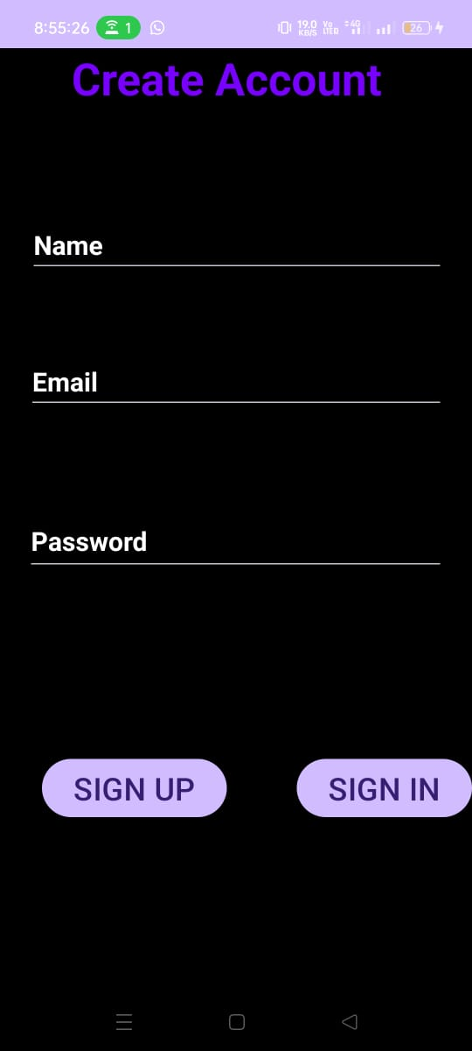 android:background="#000000"

tools:context=".MainActivity">

<Button

android:id="@+id/button1"

android:layout_width="wrap_content"

android:layout_height="wrap_content"

android:layout_marginTop="136dp"

android:text="SIGN IN"

android:textSize="24sp"

app:layout_constraintEnd_toEndOf="parent"

app:layout_constraintHorizontal_bias="1.0"

app:layout_constraintStart_toEndOf="@+id/button1"

app:layout_constraintTop_toBottomOf="@+id/editTextText2"

tools:ignore="HardcodedText,NotSibling" />

<TextView

android:id="@+id/textView"

android:layout_width="251dp"

android:layout_height="56dp"

android:text="@string/create_account"

android:textColor="#7700FF"

android:textSize="34sp"

android:textStyle="bold"

app:layout_constraintEnd_toEndOf="parent"

app:layout_constraintStart_toStartOf="parent"

app:layout_constraintTop_toTopOf="parent" />

<EditText

android:id="@+id/editTextText"

android:layout_width="318dp"

android:layout_height="42dp"

android:layout_marginTop="76dp"

android:ems="10"

android:inputType="text"

android:text="Name"

android:textColor="#FFFFFF"

android:textSize="20sp"

android:textStyle="bold"

app:layout_constraintEnd_toEndOf="parent"

app:layout_constraintHorizontal_bias="0.516"

app:layout_constraintStart_toStartOf="parent"

app:layout_constraintTop_toBottomOf="@+id/textView"

tools:ignore="HardcodedText,LabelFor,TouchTargetSizeCheck" />

<EditText

android:id="@+id/editTextTextEmailAddress"

android:layout_width="319dp"

android:layout_height="48dp"

android:layout_marginTop="56dp"

android:autofillHints=""

android:ems="10"

android:inputType="textEmailAddress"

android:text="Email"

android:textColor="#FFFFFF"

android:textSize="20sp"

android:textStyle="bold"

app:layout_constraintEnd_toEndOf="parent"

app:layout_constraintStart_toStartOf="parent"

app:layout_constraintTop_toBottomOf="@+id/editTextText" />

<EditText

android:id="@+id/editTextText2"

android:layout_width="320dp"

android:layout_height="51dp"

android:layout_marginTop="72dp"

android:ems="10"

android:inputType="text"

android:text="Password"

android:textColor="#FFFFFF"

android:textSize="20sp"

android:textStyle="bold"

app:layout_constraintEnd_toEndOf="parent"

app:layout_constraintHorizontal_bias="0.494"

app:layout_constraintStart_toStartOf="parent"

app:layout_constraintTop_toBottomOf="@+id/editTextTextEmailAddress" />

<Button

android:id="@+id/button1"

android:layout_width="wrap_content"

android:layout_height="wrap_content"

android:layout_marginStart="32dp"

android:layout_marginTop="136dp"

android:text="SIGN UP"

android:textSize="24sp"

app:layout_constraintStart_toStartOf="parent"

app:layout_constraintTop_toBottomOf="@+id/editTextText2"

tools:ignore="DuplicateIds,HardcodedText" />

</androidx.constraintlayout.widget.ConstraintLayout>